Week 3-day 1 Assignment of Adding Playwright + Typescript to Code Generator
Arc Toolkit Extension
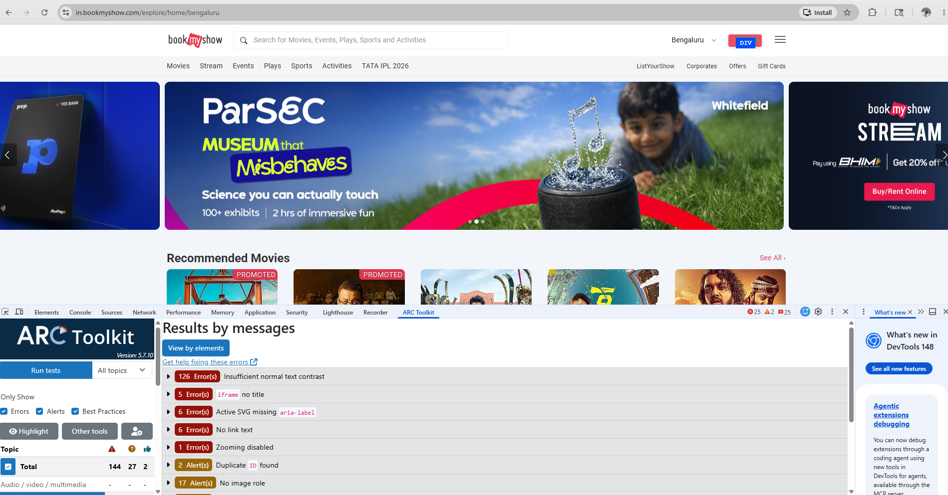
Fake Fill Extension
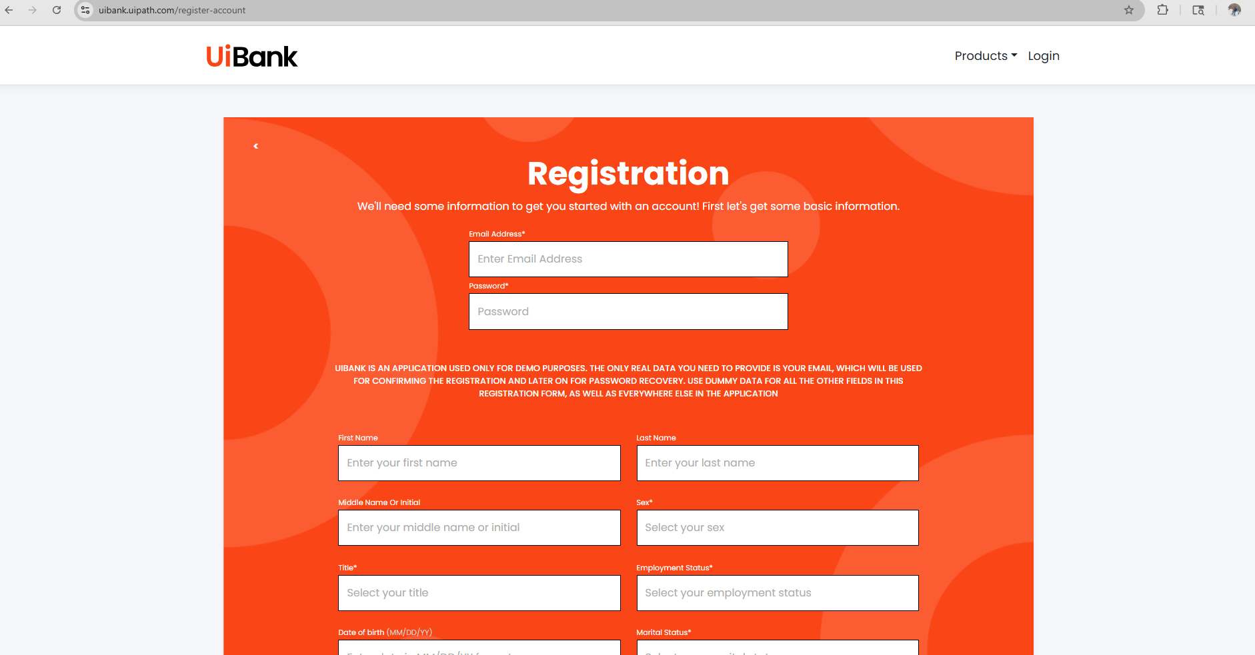
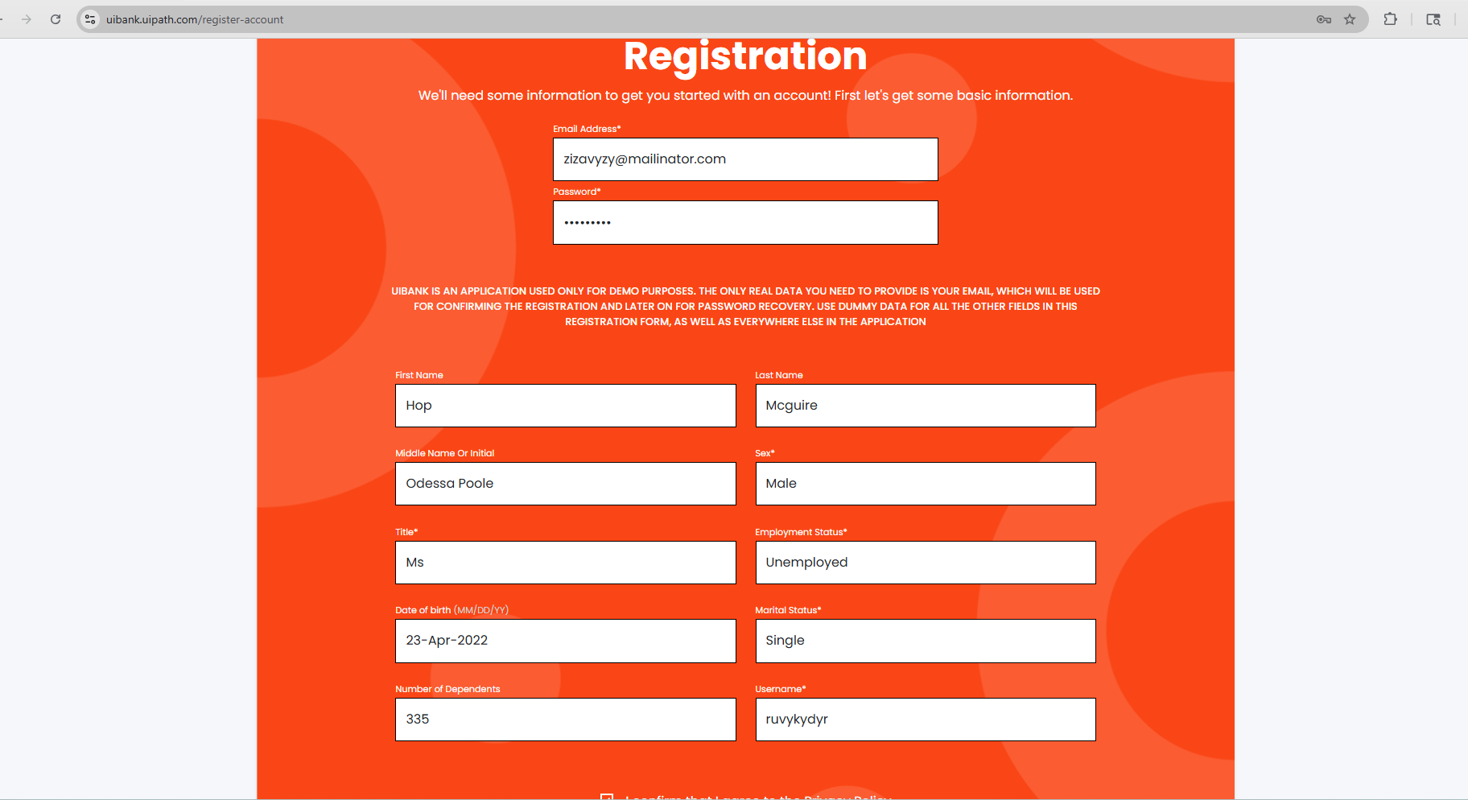
Ruto Path Finder
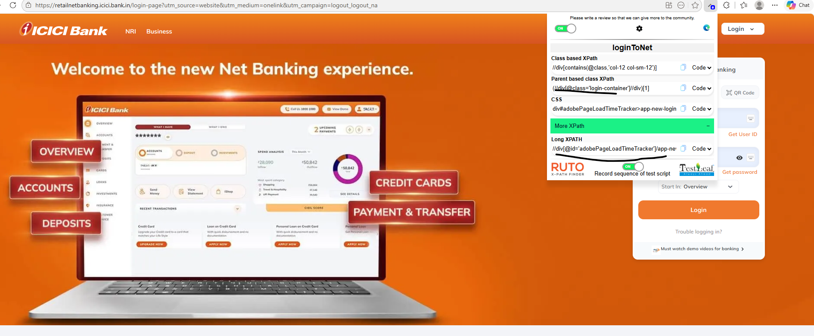

Vibe Coding for Playwright + TypeScript
Before adding Generated Code by using Java selenium
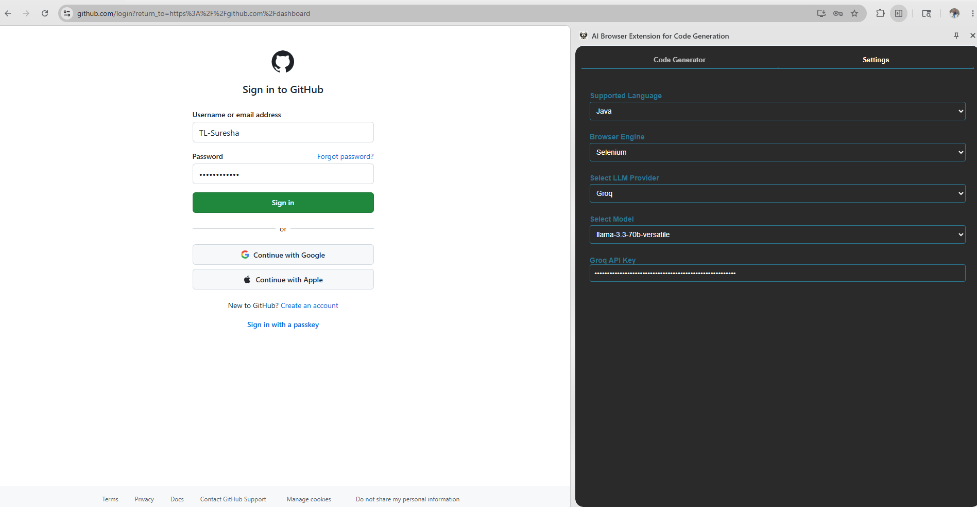
Output from code Generator:
Feature: Login to GitHub
Scenario Outline: Successful login with valid credentials
Given I open the GitHub login page
When I type "<username>" into the Username field
And I type "<password>" into the Password field
And I click the Sign in button
Then I should be logged in successfully

Examples:
| username | password |
| "testuser123" | "Test@123" |
| "seleniumuser" | "Selenium@123" |
| "cucumberuser" | "Cucumber@123" |

package com.github.stepdefs;

import io.cucumber.java.en.*;
import org.openqa.selenium.By;
import org.openqa.selenium.WebDriver;
import org.openqa.selenium.WebElement;
import org.openqa.selenium.chrome.ChromeDriver;
import org.openqa.selenium.support.ui.ExpectedConditions;
import org.openqa.selenium.support.ui.WebDriverWait;

import java.time.Duration;

public class GitHubLoginStepDefinitions {
private WebDriver driver;
private WebDriverWait wait;

@io.cucumber.java.Before
public void setUp() {
driver = new ChromeDriver();
wait = new WebDriverWait(driver, Duration.ofSeconds(10));
driver.manage().window().maximize();
}

@io.cucumber.java.After
public void tearDown() {
if (driver != null) driver.quit();
}

@Given("I open the GitHub login page")
public void openLoginPage() {
driver.get("https://github.com/login?return_to=https%3A%2F%2Fgithub.com%2Fdashboard");
}

@When("I type {string} into the Username field")
public void enterUsername(String username) {
WebElement el = wait.until(ExpectedConditions.elementToBeClickable(By.id("login_field")));
el.sendKeys(username);
}

@When("I type {string} into the Password field")
public void enterPassword(String password) {
WebElement el = wait.until(ExpectedConditions.elementToBeClickable(By.id("password")));
el.sendKeys(password);
}

@When("I click the Sign in button")
public void clickLogin() {
driver.findElement(By.name("commit")).click();
}

@Then("I should be logged in successfully")
public void verifyLogin() {
// Add verification logic here
// For example, you can check if a specific element is visible after login
WebElement success = wait.until(ExpectedConditions.visibilityOfElementLocated(By.className("header-nav-current-user")));
assert success.isDisplayed();
}
}

Adding prompt to Github copilot to add playwright and Typescript
Read my entire workspace to understand and analyze how java selenium is implemented in the codebase and tell me what are all the impacted files.
I want to implement the playwright and typescript same like selenium java
Chat output from Github Copilot
Optimized tool selection
I'll analyze your workspace to understand the Java Selenium implementation and identify all impacted files.
Now let me create a memory file with this analysis and prepare a comprehensive summary:
Based on my thorough analysis of your workspace, here's what I found:
Java Selenium Implementation - Complete Analysis
All Impacted Files:
File | Purpose | Key Changes Needed for Playwright TS
panel.html | Settings UI with language/engine selectors | Already has TypeScript + Playwright options; checkbox names need updating
chat.js | MAIN - Orchestration logic for code generation | Add TypeScript+Playwright detection; update getPromptKeys() logic
prompts.js | CRITICAL - Prompt templates for LLM | Add Playwright TypeScript prompt templates
groq-api.js | LLM provider integration | No changes needed
openai-api.js | LLM provider integration | No changes needed
testleaf-api.js | LLM provider integration | No changes needed
content.js | DOM element inspector | No changes needed
tabs.js | UI tab switching | No changes needed
bg.js | Background messaging | No changes needed
popup.js | Settings panel logic | May need language-specific checkbox labels

How Java Selenium is Implemented:
1. Detection & Routing (chat.js)
- Helper methods check language + engine: isJavaSelenium(language, engine)
- Only java + selenium combination is fully supported
- Other combinations trigger "not yet supported" message
2. Prompt Selection (chat.js - getPromptKeys())

3. Prompt Templates (prompts.js)
- SELENIUM_JAVA_PAGE_ONLY: Generates Java Page Object classes with WebDriver/Selenium imports
- CUCUMBER_WITH_SELENIUM_JAVA_STEPS: Generates .feature file + Java step definitions with WebDriver setup, explicit waits, By selectors
- CUCUMBER_ONLY: Gherkin-only feature files
4. Code Generation Flow
- User selects: Java + Selenium + DOM elements
- Selects generation modes (Feature, Page, or both)
- LLM generates code based on selected prompt template
- Displays with syntax highlighting

Implementation Status:
✅ Java + Selenium - Fully implemented
⚠️ TypeScript + Playwright - Options exist in UI but NOT implemented (shows "not yet supported")
❌ All other combinations - Not implemented

To Implement Playwright + TypeScript (Similar Pattern):
You'll need to:
- Add isTypeScriptPlaywright() helper in chat.js
- Create 2-3 new prompt templates in prompts.js:
  - PLAYWRIGHT_TYPESCRIPT_PAGE_ONLY
  - PLAYWRIGHT_TYPESCRIPT_WITH_TESTS
- Update getPromptKeys() logic to handle TypeScript + Playwright
- Optionally rename "javaGenerationMode" to generic "generationMode"
- Update loading message to show "Playwright" when TypeScript + Playwright is selected
Would you like me to proceed with implementing the Playwright + TypeScript prompts and logic following the exact same pattern as Java Selenium?

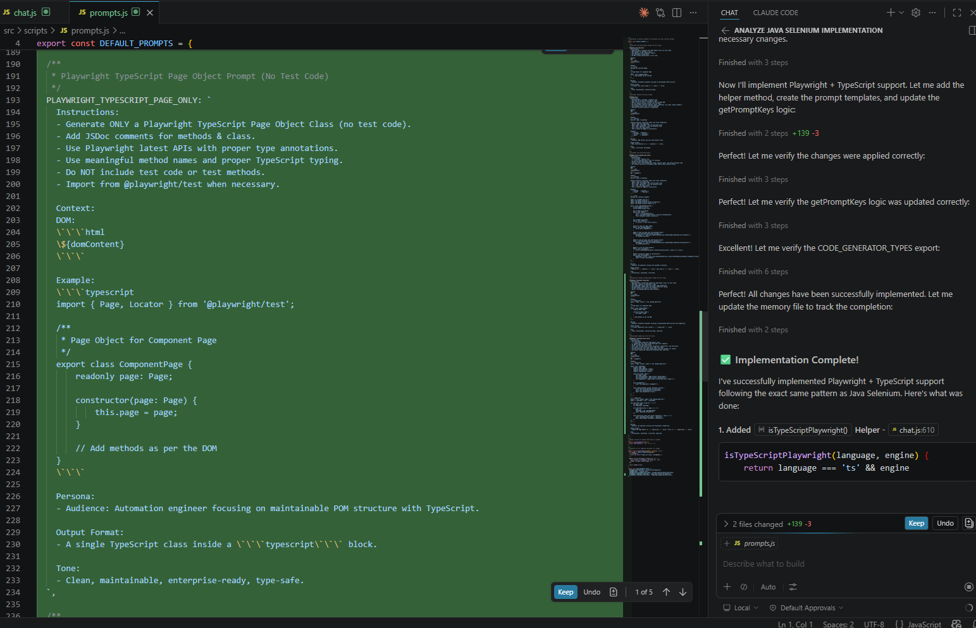

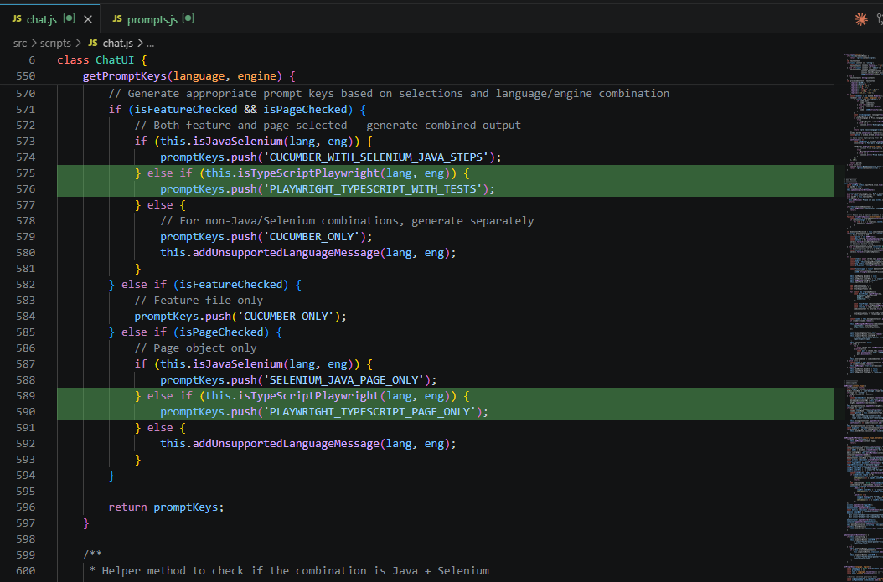
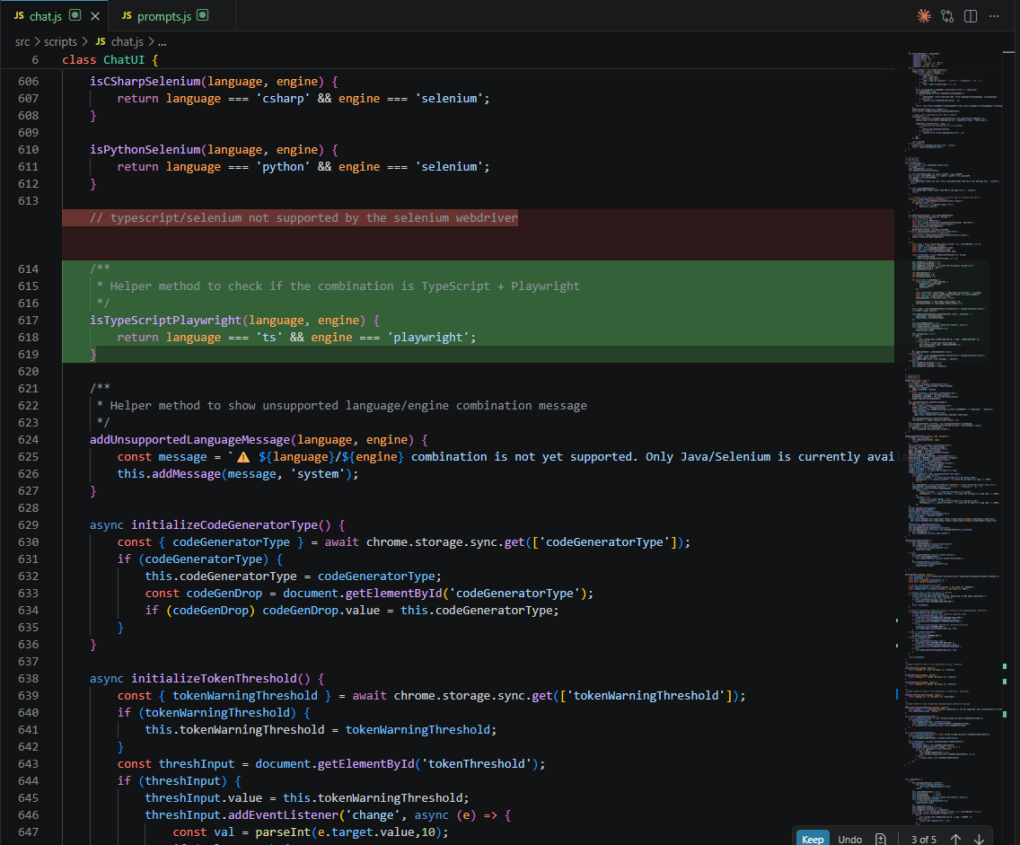
After updating the Codebase
In AI Generator
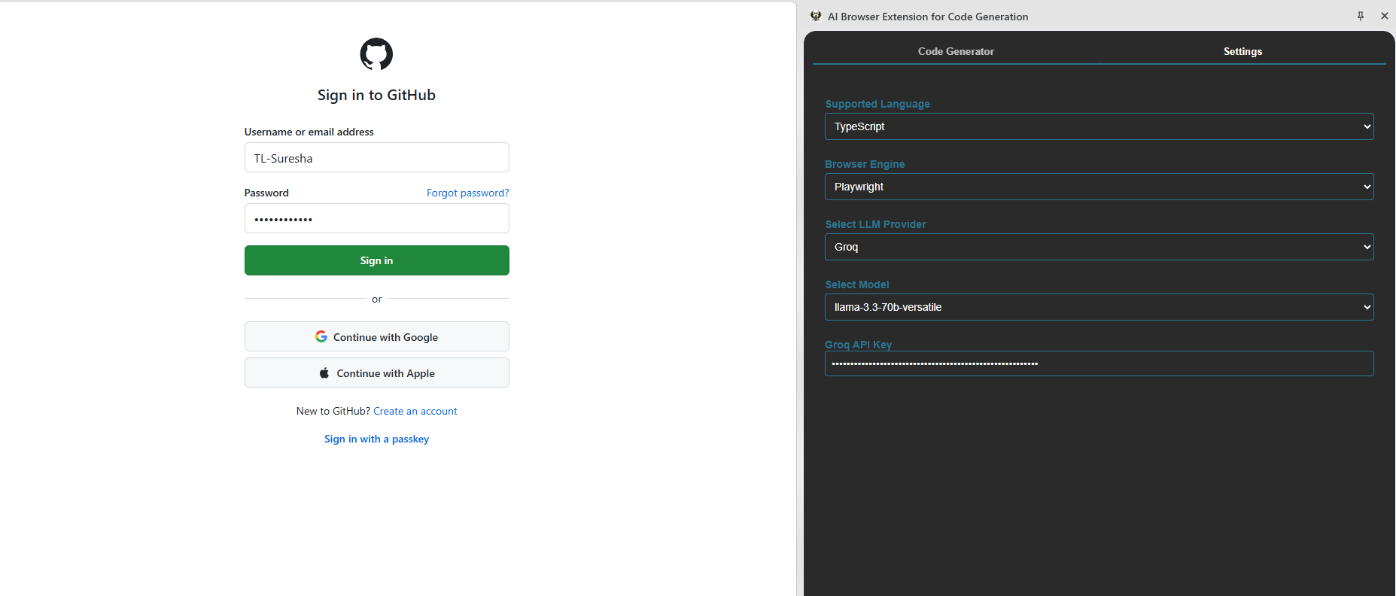
Output from code generator of test case is
import { Page, Locator, expect } from '@playwright/test';

export class LoginPage {
readonly page: Page;
readonly usernameField: Locator;
readonly passwordField: Locator;
readonly loginButton: Locator;

constructor(page: Page) {
this.page = page;
this.usernameField = page.locator('#login_field');
this.passwordField = page.locator('#password');
this.loginButton = page.locator('input:has-text("Sign in")');
}

async navigateTo() {
await this.page.goto('https://github.com/login?return_to=https%3A%2F%2Fgithub.com%2Fdashboard');
}

async login(username: string, password: string) {
await this.usernameField.fill(username);
await this.passwordField.fill(password);
await this.loginButton.click();
}
}

import { test, expect, Page } from '@playwright/test';
import { LoginPage } from './LoginPage';

test.describe('Login Scenarios', () => {
let page: Page;
let loginPage: LoginPage;

test.beforeEach(async ({ page: p }) => {
page = p;
loginPage = new LoginPage(page);
await loginPage.navigateTo();
});

test('Successful login with valid credentials', async () => {
await loginPage.login('testuser', 'testpassword123');
await expect(page).toHaveURL(/.*dashboard/);
});

test('Unsuccessful login with invalid credentials', async () => {
await loginPage.login('invaliduser', 'invalidpassword');
await expect(page).not.toHaveURL(/.*dashboard/);
});

test('Login with empty username', async () => {
await loginPage.login('', 'testpassword123');
await expect(loginPage.usernameField).toBeFocused();
});

test('Login with empty password', async () => {
await loginPage.login('testuser', '');
await expect(loginPage.passwordField).toBeFocused();
});

test('Login with valid South Indian username and password', async () => {
await loginPage.login('rameshwaran', 'tamilnadu123');
await expect(page).toHaveURL(/.*dashboard/);
});
});

